Trusted & Reliable Where Buy Verified PayPal Account
💬 Need Assistance? We’re Here 24/7!

📧 Email: usamarketit@gmail.com
💎 WhatsApp: +1(772)563-8300
🚀 Telegram: @usamarketit
🎮 discord: usamarketit
✅ Trusted Service | ⚡ Fast Response 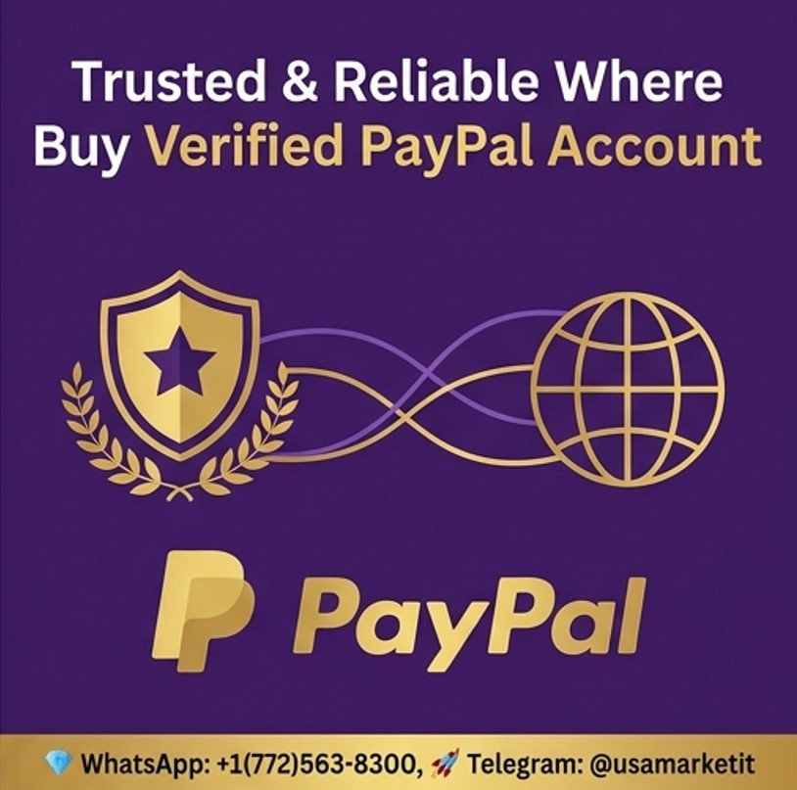
The hardest part of searching for a “trusted” place to buy a verified PayPal account isn't finding websites that advertise accounts. Search results can produce plenty of sellers claiming that their accounts are aged, verified, ready to use, or suitable for particular countries.
The harder question is whether the account can actually belong to you in a way that remains workable after the first login.
PayPal's verification system is designed around identifying customers and, where required, their businesses. Its current documentation says it may request government-issued identification, proof of address, and other information.
That changes how the idea of a “trusted seller” should be evaluated. Instead of looking for a marketplace that promises a ready-made account, the more useful approach is to understand what makes a payment account trustworthy in the first place.

What People Usually Mean by a “Trusted” PayPal Account Seller
When someone searches for a reliable seller, they may be looking for several things at once:
- An account that has already passed some form of verification
- A particular country or currency
- A business account
- An account with an established history
- Access to receiving payments
- A quick alternative to registration
- A seller offering replacement guarantees
- A low-cost account
These requirements sound practical, but they don't answer the most important ownership question.
Who is PayPal actually recognizing as the account holder?
If the account was created using another person's identity, then the account's apparent verification may not solve your verification problem.
PayPal's published documentation emphasizes identity matching and supporting documentation. It also says that a name cannot simply be changed to another person's name on a U.S. account.

What Makes a PayPal Account Trustworthy?
A trustworthy payment account should have a clear connection between the person or organization using it and the information supplied to PayPal.
That usually means:
- The account is opened by the actual user.
- The personal or business information is accurate.
- Required identity checks are completed legitimately.
- Connected financial accounts belong to or are authorized by the user.
- Login and recovery information are controlled by the account holder.
- Transactions reflect genuine activity.
- The user can respond to future verification requests.
This is very different from simply buying credentials.

Why “Fully Verified” Is Not Enough
An online advertisement may describe an account as “fully verified.”
That phrase doesn't tell you:
- Who verified it
- Which documents were used
- Whether the documents belong to you
- What country the original owner lives in
- What transaction history exists
- Whether limitations are already present
- Whether the original owner retains recovery access
- Whether your future bank information will match
- Whether PayPal will accept you as the actual account holder
Verification is contextual.
For example, PayPal says that identity documents submitted for an account limitation should match the information on the PayPal account.
That requirement can become a major issue when someone attempts to operate an account originally created under another identity.

How to Research a Seller Without Automatically Trusting the Listing
If you encounter an account-selling website, don't treat its testimonials or guarantees as proof of legitimacy.
Instead, examine the offer critically.

Check the seller's business identity
Look for information about the company behind the website.
Ask:
- Is there a real business name?
- Is there a verifiable contact method?
- Are terms clearly published?
- Is there a privacy policy?
- Is the refund policy understandable?
- Does the company explain what it actually sells?
- Does it make unrealistic guarantees?
A polished website isn't proof that a seller is legitimate.

Look at the payment method
Be cautious when a seller insists on irreversible payment methods.
A payment method that gives you no practical dispute mechanism can leave you exposed if the account never arrives or stops working immediately.

Read the guarantee carefully
“Replacement guarantee” can sound reassuring, but ask what replacement actually means.
Does it cover:
- Login failure?
- Identity verification failure?
- Account limitation?
- Payment rejection?
- Recovery by the original owner?
- A particular number of days?
If the terms are vague, the guarantee may not provide the protection you expect.

Why Country-Specific PayPal Accounts Require Care
A major part of the online account market revolves around country-specific listings.
You may see phrases such as:
- USA PayPal account
- UK PayPal account
- Canadian PayPal account
- German PayPal account
- French PayPal account
- Spanish PayPal account
But a country label doesn't change your actual residency or identity.
PayPal services and requirements can vary between countries. Its U.S., UK, German, and other regional agreements and help pages demonstrate that PayPal maintains jurisdiction-specific terms and procedures.
A legitimate account should therefore reflect your real circumstances.

Why Sellers May Claim That an Account Is “Aged”
An “aged” account is generally described as an account that has existed for a period of time.
Some sellers claim that older accounts are more valuable because they appear established.
But age alone doesn't guarantee reliability.
An old account can still have:
- Previous disputes
- Unusual transaction patterns
- Account limitations
- Security problems
- Outdated contact information
- Previous payment methods
- A history you cannot independently verify
PayPal says account limitations can occur for reasons including unauthorized activity, regulatory requirements, and unusual or higher-risk activity.
Therefore, age should never be treated as a substitute for legitimate ownership.

A More Reliable Approach: Build the Account Yourself
If you need PayPal for business or personal payments, building the account around your actual identity is usually more practical.

Step 1: Confirm PayPal availability
Start with PayPal's official website for your country.
Check whether the services you need are available.

Step 2: Choose personal or business
PayPal distinguishes between personal and business accounts.
If you're primarily selling products or services, a business account may be the appropriate structure. PayPal's U.S. agreement specifically says users primarily engaged in commercial activity should use a business account.

Step 3: Enter accurate information
Use your actual legal and contact information.
Don't use:
- A fake address
- A borrowed identity
- Someone else's phone number
- Another person's bank information
- False business documents

Step 4: Complete requested verification
Follow the instructions inside PayPal.
The exact requirements vary. PayPal may request government-issued identification, proof of address, business information, or other documentation.

Step 5: Connect legitimate financial information
If you add a bank account, make sure the information is compatible with PayPal's requirements.
PayPal explains that account and bank names may need to match for transfers.

Step 6: Start with normal activity
Don't assume that a new account should immediately process unusually large transaction volumes.
Build your payment activity around genuine sales, purchases, invoices, or other legitimate transactions.
PayPal notes that unusual increases in sales volume can contribute to account review or limitation in some circumstances.

What to Do If PayPal Requests More Information
A verification request doesn't necessarily mean something has gone wrong.
Payment providers sometimes need additional information to satisfy regulatory or risk requirements.
If PayPal requests documentation:
- Log in directly to PayPal.
- Read the exact request.
- Check which documents are required.
- Submit clear, valid documents.
- Ensure the information matches your account.
- Keep copies of what you submitted.
- Monitor your Resolution Center.
PayPal says documents submitted for limitation reviews should be legible and match the account information.

What If Your Account Is Limited?
A limitation can affect your ability to send, receive, or withdraw money.
PayPal recommends checking the Resolution Center or account notifications for instructions.
Avoid creating another account using somebody else's information simply to bypass a restriction.
PayPal's published agreements prohibit various attempts to circumvent account restrictions, including opening additional accounts using information that isn't your own in relevant circumstances.
The appropriate response is to understand why the limitation occurred and complete the requested review process.

Red Flags When Looking at Account Sellers
Here are warning signs worth taking seriously.

“Guaranteed forever”
No responsible seller can guarantee how a third-party payment platform will treat an account indefinitely.

“No verification needed”
If a payment service requires identity information, a seller cannot legitimately remove those regulatory requirements.

“Use our documents if PayPal asks”
This is a major warning sign.
Your payment account should not depend on continuing access to another person's identity documents.

“Change the account name later”
Don't assume this is possible.
PayPal's U.S. documentation explicitly says an account name can't simply be changed to another person's name.

“Unlimited transactions”
Account functionality and limits can vary. A seller's promise doesn't override PayPal's rules.

“No risk”
Payment accounts always involve financial and compliance considerations. A claim of zero risk should make you more cautious, not less.

Comparing the Main Options
Approach | Setup speed | Ownership clarity | Verification control | Long-term practicality
Buy another person's account | May appear fast | Low | Low | Uncertain
Create your own personal account | Moderate | High | High | Strong
Create your own business account | Moderate | High | High | Strong for commercial use
Use another legitimate payment provider | Depends on provider | High | High | Depends on country and use
The table isn't about promising that one service works for everyone. Your location, business model, customers, currencies, and payment requirements should determine the appropriate option.

Expert Tips for Choosing a Payment Solution
Think about the entire payment lifecycle rather than just account creation.
Ask:
- How will customers pay me?
- How will I withdraw funds?
- What currencies do I need?
- What fees apply?
- What documentation might be required?
- What happens if a payment is disputed?
- Does the provider support my country?
- Can the account be used for my business model?
- Can I independently control the account?
This approach is much more useful than choosing a payment account solely because an advertisement calls it “verified.”

Frequently Asked Questions

Where can I buy a trusted verified PayPal account?
Online sellers advertise verified PayPal accounts, but an advertised account isn't automatically transferable or suitable for a new user. A safer approach is to open your own account through PayPal and complete the verification process using your own information.

Can I trust reviews on an account-selling website?
Reviews can provide clues, but they shouldn't be treated as independent proof. Look for verifiable information about the company, clear policies, realistic claims, and payment protections. Testimonials alone cannot establish that an account will remain usable.

Does an aged PayPal account have better limits?
Not necessarily. Account age doesn't guarantee higher limits or continued access. PayPal can review accounts based on regulatory requirements, unauthorized activity, disputes, unusual activity, or other risk factors.

Can I use my own bank account with a purchased PayPal account?
You shouldn't assume that this will work smoothly. PayPal documentation indicates that the name on a PayPal account and bank account may need to match for relevant transfers.

Can I change the name after purchasing a PayPal account?
You should not rely on that. PayPal says a U.S. account name cannot be changed to another person's name.

Why does PayPal ask for identification?
PayPal may need to verify customers for regulatory and security reasons. Depending on the country and account type, this can involve government-issued identification, proof of address, business documentation, or additional checks.

What should I do if a seller asks for my passport?
Be extremely cautious about sharing sensitive identity documents with an unknown seller. If PayPal needs identity documents, submit them through PayPal's official verification process rather than sending them to an unrelated account seller.

Can a verified PayPal account still become limited?
Yes. Verification doesn't guarantee permanent unrestricted access. PayPal says accounts can be limited for several reasons, including regulatory requirements, unauthorized activity, and higher-risk activity.

Is a business PayPal account suitable for freelancers?
It can be, depending on the freelancer's activity and country. PayPal says business accounts are intended for commercial activity, while personal accounts are intended for personal, family, or household use.

What is the safest way to get a verified PayPal account?
Create an account using your own accurate information, select the correct account type, connect legitimate payment methods, and complete PayPal's verification requirements directly.

Conclusion
A trustworthy PayPal account isn't defined by a seller's advertising language. It is defined by clear ownership, accurate identity information, legitimate payment methods, appropriate account use, and the ability to respond to future verification requests.
That is why researching a “trusted seller” is only part of the problem. The more important question is whether the account can genuinely and legitimately support your own identity and financial activity.
If your goal is simply to receive payments or operate an online business, start by identifying that need and then choose the legitimate payment solution that supports it. A few extra steps during registration can be far less costly than dealing with an account whose history and ownership you cannot control.

Call to Action
Before paying anyone for a “verified” PayPal account, check PayPal's official requirements for your country and determine whether you can open and verify your own account. Use official verification channels, keep your documentation consistent, and treat promises of instant, permanent, or risk-free access with caution.

